**ASSIGNMENT 3**

THIS WEEK'S ASSIGNMENT WE ARE GIVEN TO TAKE TWO COMPANIES ONE FROM THE TECH SECTOR AND ANOTHER FROM THE CONSUMER GOODS SECTOR I AM TAKING **TECH MAHINDRA** **& BRITANNIA** COMPANY WHICH BOTH ARE REPUTABLE COMPANIES IN THAT WE ARE FINDING

* **COMPETITIVE ADVANTAGE**

1. BRAND REPUTATION
2. PRODUCT DIFFRENTIATION
3. TECHNOLOGICAL INNOVATION
4. MARKET LEADERSHIP
5. ECONOMIES OF SCALE
6. DISTRIBUTION NETWORK

* **ANALYSING FINANCIAL PERFORMANCE**

1. REVENUE GROWTH
2. PROFIT MARGINS
3. ROI
4. MARKET SHARE

* **COMPARING COMPETITIVE POSITIONS**
* **ASSESSING SUSTAINABILITY**
* **CONCLUSION**

Analyzing the competitive advantage of tech Mahindra and Zomato

**Introduction:**

**TECH MAHINDRA:**

Tech Mahindra is an Indian multinational information technology services and consulting company. Part of the Mahindra Group, the company is headquartered in Pune and has its registered office in Mumbai. Tech Mahindra has over 146,000 employees across 90 countries. The company was ranked #5 in India's IT firms and overall No. 47 on Fortune India 500 list for 2019.

On 25 June 2013, Tech Mahindra announced the completion of a merger with Mahindra Satyam. Tech Mahindra is one of the top Big Tech (India) companies. Tech Mahindra has 1,262 active clients as of June 2022**.**

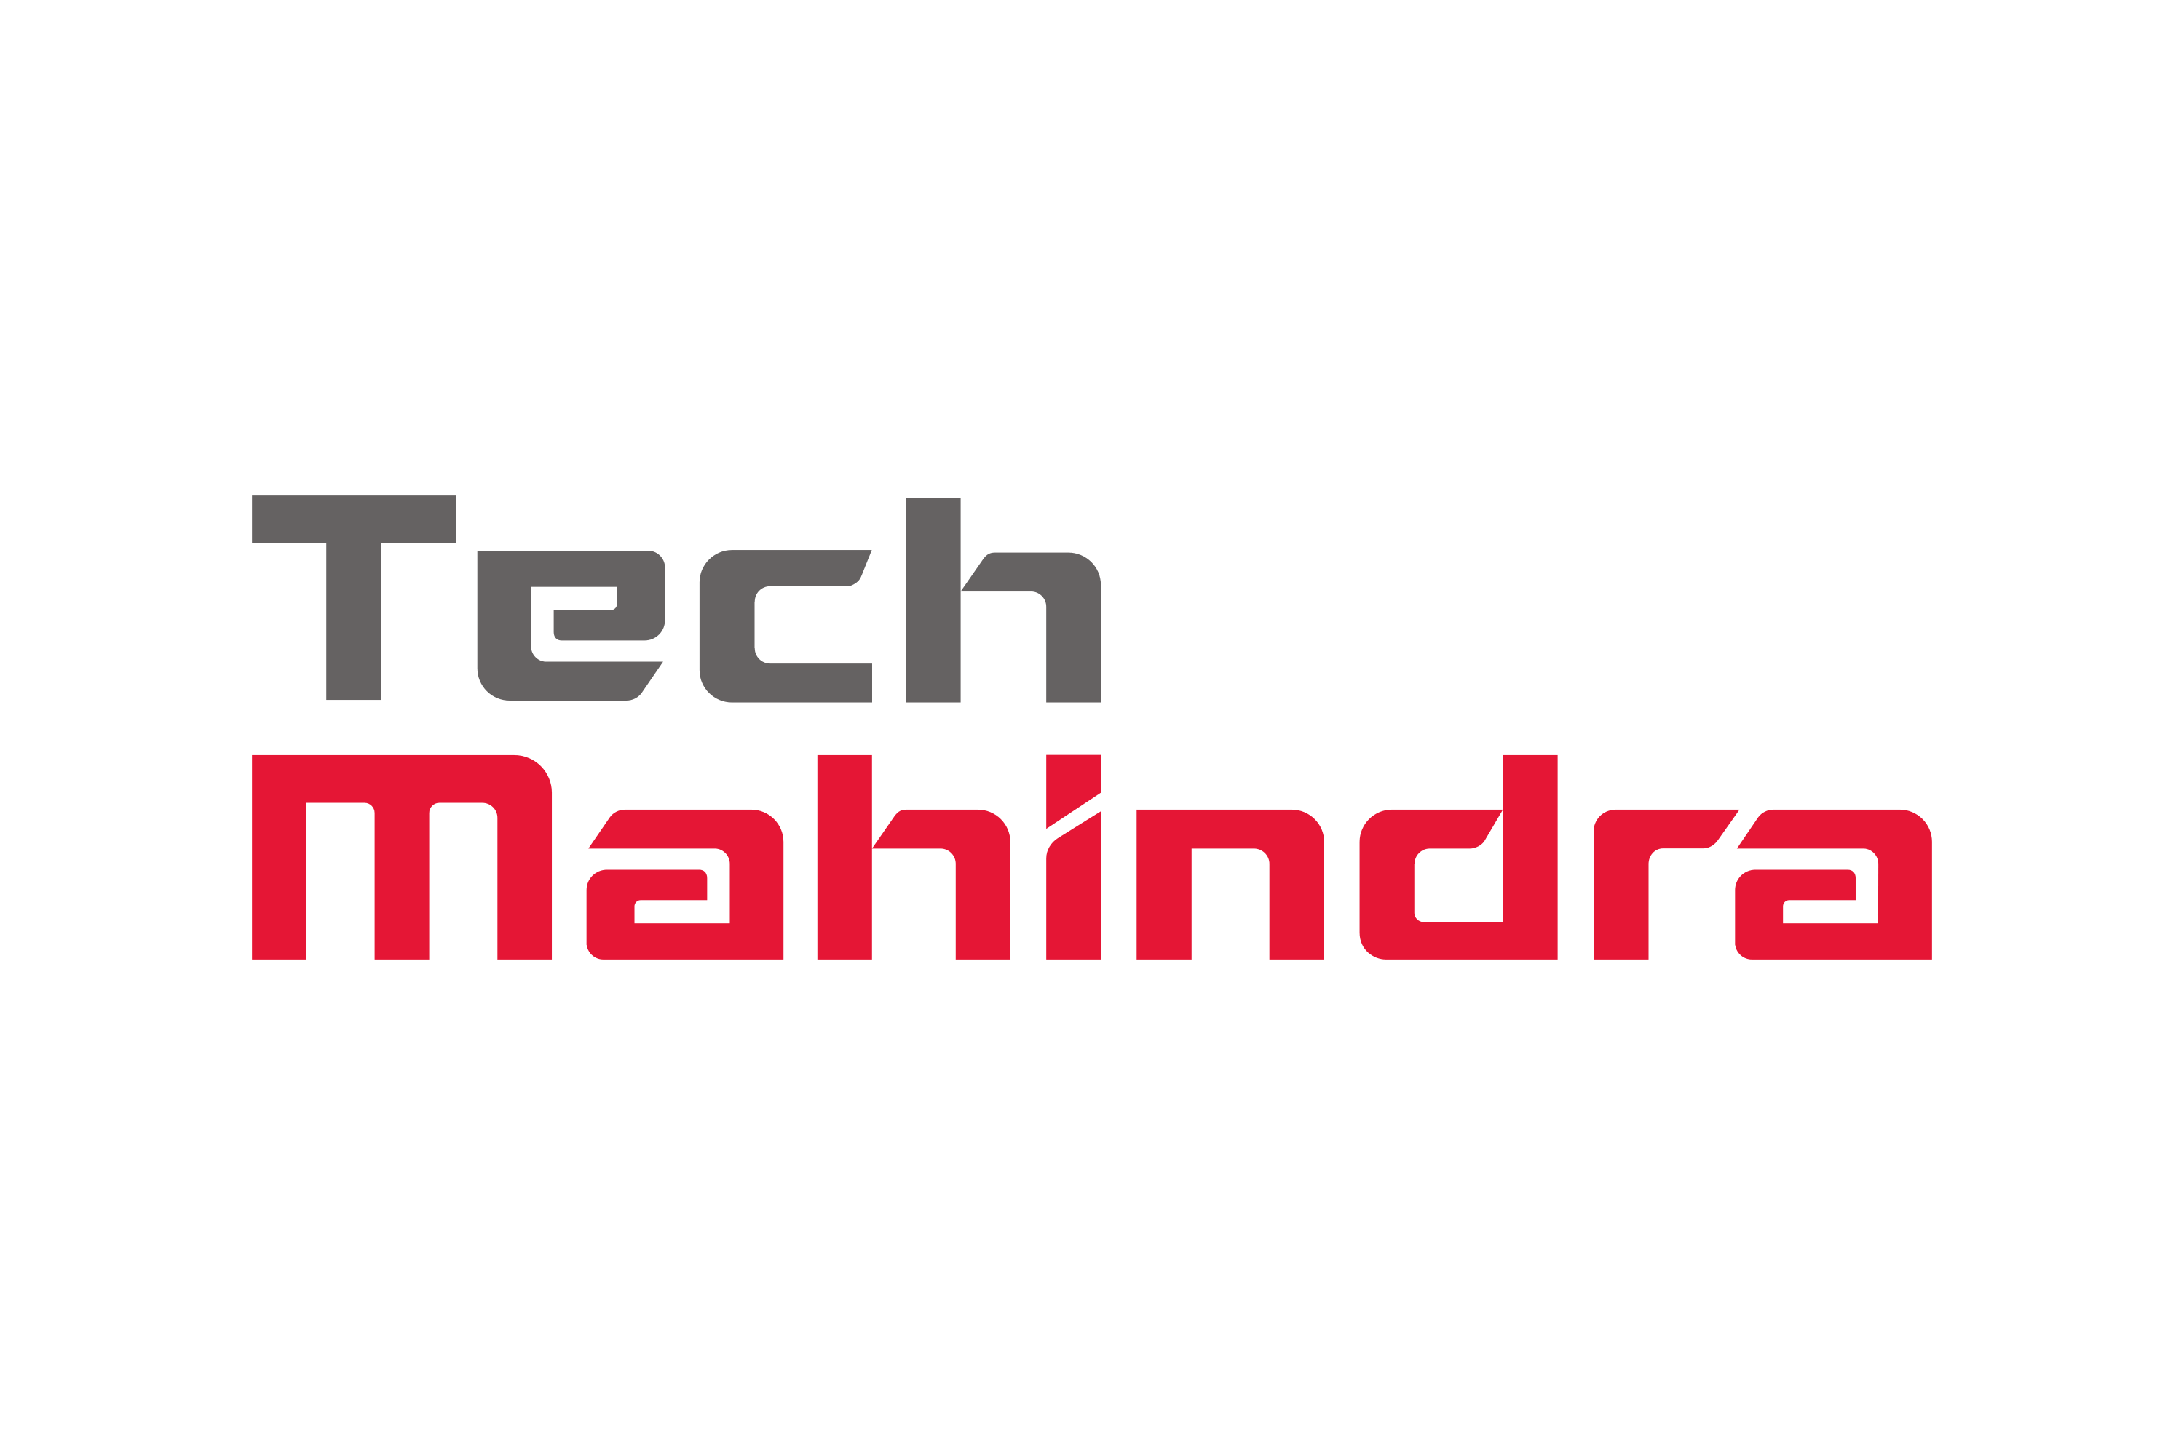

**BRITANNIA:**

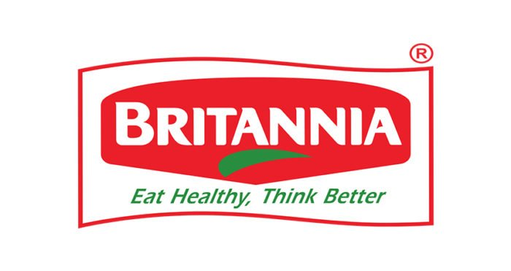

Britannia Industries Limited (BIL) is a multinational food products company that was founded in Kolkata in 1892. BIL is one of India's oldest companies and a leading FMCG company. The company's products include bakery items such as biscuits, breads, cakes, wafers, rusk, and croissants, and dairy products such as milk, cheese, butter, and yogurt. BIL's brand portfolio includes **Tiger, Marie Gold, Good Day, 50:50, Treat, NutriChoice, and Milk Bikis.**

**BACKGROUND**

**TECH MAHINDRA:**

Mahindra & Mahindra started a joint venture with British Telecom in 1986 as a technology outsourcing firm. Then the company was named Mahindra British Telecom (MBT). Later it was renamed as Tech Mahindra. British Telecom initially had around a 30 percent stake in Tech Mahindra. In December 2010, British Telecom sold 5.5 percent of its stake in Tech Mahindra to Mahindra & Mahindra for Rs. 451 crore. In August 2012, British Telecom sold 14.1 percent of its stake to institutional investors for about Rs. 1,395 crore. In December 2012, British Telecom sold its remaining 9.1 percent (11.6 million shares) shareholding to institutional investors for a total gross cash proceeds of Rs. 1,011.4 crores. This sale marked the exit of British Telecom from Tech Mahindra.

**BRITANNIA**

The company was established in 1892 by a group of British businessmen with an initial investment of ₹295.[10] Initially, biscuits were manufactured in a small house in central Kolkata. Later, the enterprise was acquired by the Gupta brothers, mainly Nalin Chandra Gupta, an attorney, and operated under the name, V.S. Brothers. In 1918, C.H. Holmes, an English businessman based in Kolkata, was taken on as a partner and The Britannia Biscuit Company Limited (BBCo) was launched. The Mumbai factory was set up in 1924 and Peek Freans acquired a controlling interest in BBCo. During World War II, the government of British India needed a continuous supply of biscuits for British soldiers. The Britannia Biscuit Company started supplying biscuits to the British Army for several years, and the company sometimes devoted 95% of its capacity to produce biscuits for the armed forces. Biscuits were in high demand during World War II, which gave a boost to the company's sales. The company name was changed to the current Britannia Industries Limited in 1979. In 1982, the American company Nabisco acquired the parent of Peek Freans and became a major foreign shareholder. In 1978, Britannia came out with its public issue, and its Indian shareholding had increased to 62%, which firmly established Britannia as an Indian company. The 38% foreign stake was owned by the UK-based Associated Biscuits International Limited (ABIL).

**Competitive advantage**

|  |  |  |
| --- | --- | --- |
| **BASIS** | **TECH MAHINDRA** | **BRITANNIA** |
| BRAND reputation  Product diffrentiation | Tech Mahindra has a strong reputation in 2023, including being recognized as the only Indian IT company to make the Dow Jones Sustainability Indices for the ninth year in a row. It also received a double "A" rating for transparency on climate change and water security from CDP's 2023 questionnaires and was ranked number one in the S&P GlobalSustainability Yearbook 2023. | Britannia Industries is a food brand that has a strong reputation for its quality products and consistent taste. In 2022, Kantar India's Brand Footprint report ranked Britannia fourth in India's most chosen FMCG brands. The Economic Times also named Britannia's Good Day biscuit brand the Brand Equity's Most Trusted Brands of Indians in 2019-20. Britannia is also the market leader in Nepal.  as ranked 4th in the list of India's most chosen FMCG brands, as per Kantar India's annual Brand Footprint report. Britannia won the Global Sustainability Leadership Awards from the World Sustainability Congress in 2021. The Economic Times listed the company's Good Day biscuit brand as the Brand Equity's Most Trusted Brands of Indians in 2019-20. The company was selected for special recognition under the Leading RE Investor category at the Renewable Energy India Awards 2016. |